LAB IMPLEMENTATION EXPERIMENT 2
Text Preprocessing, Tokenization and Word Embeddings for Natural Language Processing
Generative AI Laboratory (CO1, CO2)
Date: [Enter date of experiment / submission]
Aim
To preprocess BattingCoach-domain text, perform tokenization, stop-word removal, stemming and lemmatization, and create word and sentence embeddings for analysing the textual representation of cricket-coaching information.
Theory
Natural Language Processing (NLP) enables computers to process and represent human language. Text collected from documentation often contains inconsistent capitalization, punctuation, whitespace and common words that may not be useful for a particular analysis. Preprocessing standardizes the text before it is passed to an NLP model.
Tokenization divides text into smaller units called tokens. Basic word tokenizers split on whitespace or punctuation, whereas Transformer tokenizers often use subword units such as WordPiece or Byte Pair Encoding. Subword tokenization can represent uncommon words by combining smaller known pieces.
Stop-word removal filters frequent words such as “the”, “is” and “of”. Stemming heuristically removes suffixes, while lemmatization maps a word to its dictionary form. Word2Vec learns static dense vectors from local word context; Sentence Transformers produce contextual sentence-level vectors that can be compared using cosine similarity.
Dataset note: the repository’s Roboflow dataset contains images rather than a ready-made text corpus. Therefore, this notebook uses a small, clearly labelled corpus built from BattingCoach README facts, documented stroke names and coaching vocabulary. It is a project-domain text sample, not the raw image dataset.
Steps
1. Install NLTK, Gensim, Transformers, Sentence Transformers and the required numerical libraries.
2. Create a small textual corpus from the BattingCoach project documentation and cricket-shot terminology. Keep each sentence as a separate document.
3. Convert the text to lowercase and remove punctuation and unwanted symbols using regular expressions.
4. Tokenize the cleaned text and remove English stop words. Compare the original sentence with its processed tokens.
5. Apply Porter stemming and WordNet lemmatization to a set of sample terms such as playing, drives and classified.
6. Use the DistilBERT tokenizer to inspect subword tokens and token IDs for a project-domain sentence.
7. Train a small Word2Vec model on the prepared sentences and inspect the vector dimensions and nearest terms for selected words.
8. Generate contextual sentence embeddings using all-MiniLM-L6-v2. Record the embedding matrix shape.
9. Apply PCA to reduce sentence embeddings to two dimensions and plot the project-domain sentences. Interpret the chart cautiously because the corpus is small.
Code
Core implementation excerpt (the complete runnable workflow is provided in the corresponding notebook).
%pip -q install nltk gensim transformers sentence-transformers scikit-learn
import re, nltk
from nltk.corpus import stopwords
from nltk.stem import PorterStemmer, WordNetLemmatizer
from gensim.models import Word2Vec
from transformers import AutoTokenizer
from sentence_transformers import SentenceTransformer
nltk.download("stopwords", quiet=True)
nltk.download("wordnet", quiet=True)
sentences = [
"The cover drive uses a stable front-foot stride and a high leading elbow.",
"The straight drive requires balance and a vertical bat face.",
"The pull shot is a horizontal cross-bat stroke.",
"BatCoach analyses body landmarks with MediaPipe and detects the bat using YOLOv8-OBB."
]
stop = set(stopwords.words("english"))
def preprocess(text):
text = re.sub(r"[^a-z0-9\s]", " ", text.lower())
return [w for w in text.split() if w not in stop]
processed = [preprocess(s) for s in sentences]
stemmer, lemma = PorterStemmer(), WordNetLemmatizer()
print("Processed:", processed)
print("Stem / lemma:", [(w, stemmer.stem(w), lemma.lemmatize(w))
for w in ["playing", "drives", "classified"]])
w2v = Word2Vec(processed, vector_size=50, window=3,
min_count=1, workers=2, sg=1, seed=42, epochs=200)
print("Word2Vec vocabulary:", len(w2v.wv))
print("Vector shape:", w2v.wv["drive"].shape)
tok = AutoTokenizer.from_pretrained("distilbert-base-uncased")
print("Subword tokens:", tok.tokenize(sentences[0]))
embedder = SentenceTransformer("sentence-transformers/all-MiniLM-L6-v2")
emb = embedder.encode(sentences, convert_to_numpy=True)
print("Sentence embedding matrix:", emb.shape)
Output
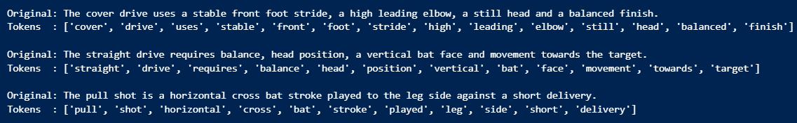

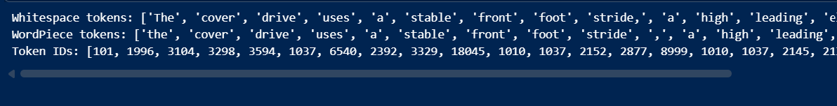

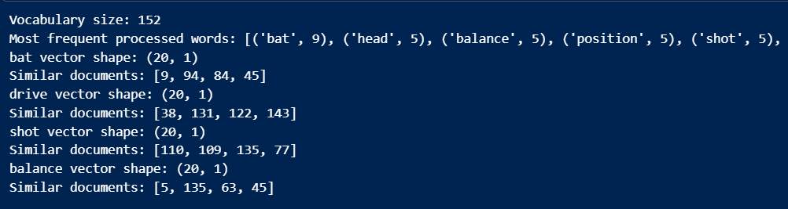

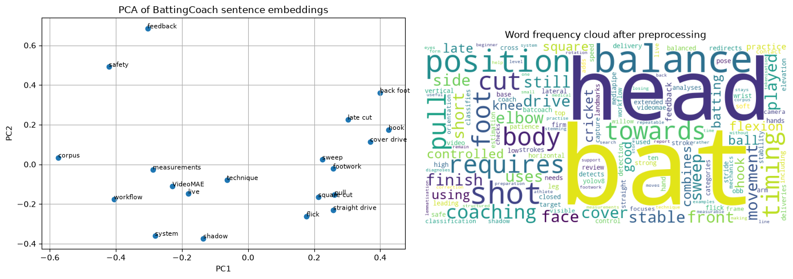

Observation
Compare the original and processed sentences. Mention any information lost through stop-word removal, differences between stemming and lemmatization, the Word2Vec vector dimension, the sentence-embedding dimension and visible groupings in the PCA plot. State that a small corpus gives illustrative rather than production-quality embeddings.
Conclusion
The experiment demonstrates the main stages of NLP text preparation using BattingCoach-domain text. Preprocessing standardizes the corpus, tokenization converts words into model-ready units, and embedding methods convert text into numerical representations. After execution, record the vector sizes and describe how static Word2Vec embeddings differ from contextual sentence embeddings.

